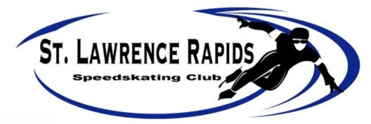

2020-2021 Club Membership
Name: | Date of Birth: mmm/dd/yyyy
Address: | Phone #s:  (H)  (W)  (C)
Brockville Resident:___ yes ___no (Township___________________________________) | Health Card #: (optional)
Email Address: (required) | Emergency Contact: (Other than numbers above)
Allergies or Health Information: | SSC#:
 | Club Skate Rental #:
Fees:
Learn-To-Skate Membership (Sept 16 – Nov 4), (Nov 11 – Jan 6) or (Jan 13 – Mar 3) $150 each session
Trial Membership: $100 (4 consecutive sessions including skate rental)
Youth 1 Night per week program $600
Youth 2 Nights per week program $800
Youth 3 Nights per week program $1250
Master $650 (1 session/wk) or $900 (2 sessions/wk)
Family Member Associate Fee: (recommended) $50
Name & D.O.B of Associate Member:
Total Fee:
Membership extends from September 1, 2020 to August 31, 2021
2 Cheques may be dated: no later than Sept 7, 2020 & Nov 1, 2020
No Refunds will be granted after the start of the speed skating season September 8, 2020. Cheque(s) payable to: “St. Lawrence Speed Skating Club” or “SLSSC”
WAIVER:
I hereby authorize emergency medical or surgical treatment for myself and/or my daughter/son/ward if such treatment is required while I or my daughter/son/ward is participating in the St. Lawrence Rapids Speed Skating Club, Ontario Speed Skating Association (OSSA) or Speed Skating Canada (SSC) activities. I hereby, for myself, my heirs,
executors and assign, waive and release any damages I may have against the St. Lawrence Rapids Speed Skating Club, and the City of Brockville or their agents for any damages.

SIGNATURE: _____________________________________ DATE: ____________________________________ (if under 17 years of age or younger-parent/guardian)
PHOTO WAIVER:
The applicant grants the Club the right for display or promotional purposes, the use of any photographs taken of the applicant and/or family members, and waives/releases any claim related to such use.

Membership Catergory | Amount Paid
 | Fee Amount Cash or Chq #’s:

